Q No. 1

Prepare sales bills using simple formula the include: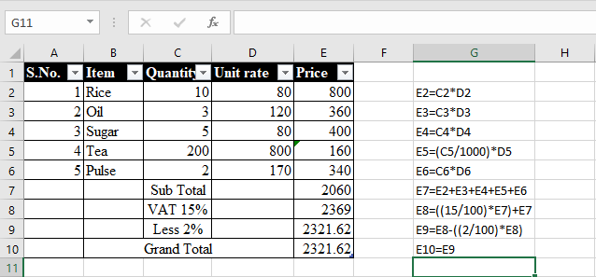

Q No. 2

Find the average marks of the student:

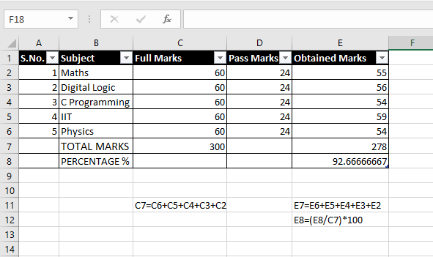

Q No. 3

Find the total no. of boys and girls of the given class.

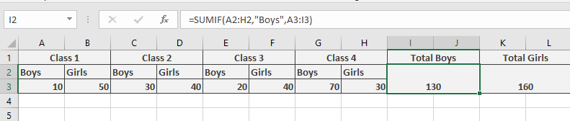

Q No. 4

Find the total number of people whose age is above 30.

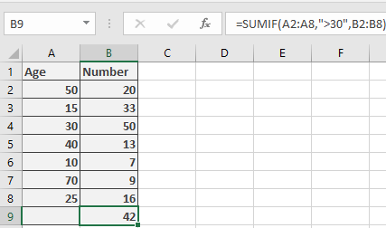

Q No. 5

Find the total no. of people whose :

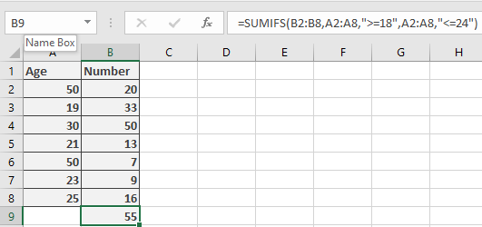24>=Age>=18

Q No. 6

Mark the student as Pass who scores>=40 and fail who scores <40 in the subjects. Use IF function.

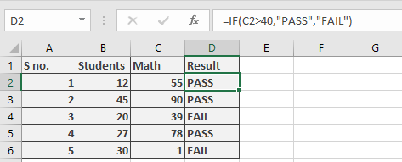

Q no. 7

Calculate the commission of sales on the basis of following criteria. Use Nested If function. 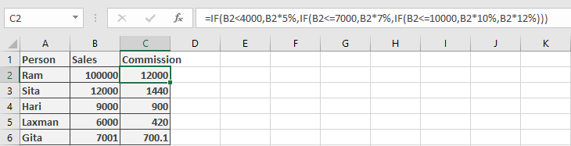

Q No. 8

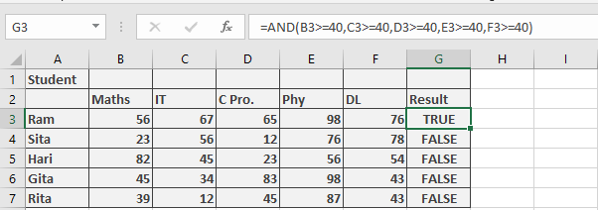Mark the student as True Who Pass in all subject and FALSE who fail.

Q No. 9

Mark the student who pass in all subject else fail using If..And.

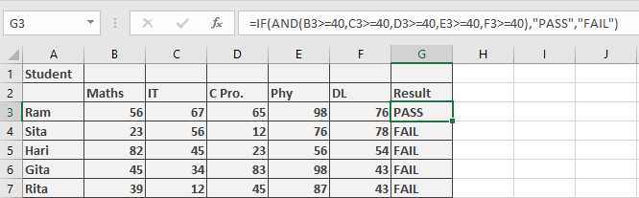

Q No. 10

Find round, ceiling.

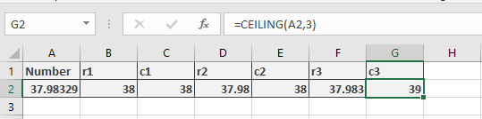

Q No. 11

Find Quotient and reminder.

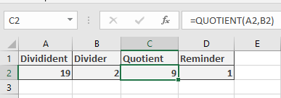

Q No. 11

Find the Distinction of the students.  
